TWO

Abe vows ¥55 billion in aid to Pacific states
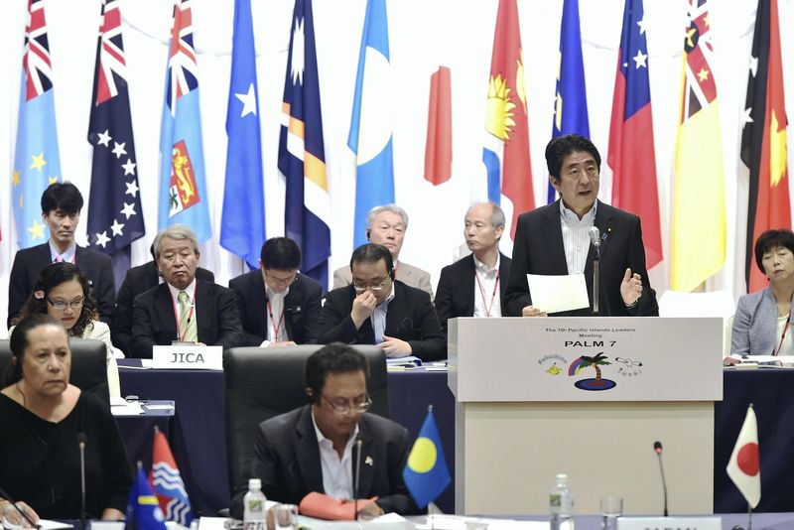
The Yomiuri Shimbun
Prime Minister Shinzo Abe gives a speech at the seventh Pacific Islands Leaders Meeting in Iwaki, Fukushima Prefecture, on Saturday.
8:36 pm, May 23, 2015
The Yomiuri Shimbun IWAKI, Fukushima — Prime Minister Shinzo Abe pledged to provide more than ¥55 billion in aid over the next three years for measures against climate change and natural disasters at the Pacific Islands Leaders Meeting (PALM) in Iwaki, Fukushima Prefecture, on Saturday.
Abe also unveiled a plan in which Japan, as a nation with a high level of safety preparedness, will actively train about 4,000 experts in disaster prevention and other fields through people-to-people exchanges.
Held by Japan every three years, the seventh PALM meeting was attended by leaders and ministers of 17 countries: 14 island nations, such as Fiji, Palau and Niue, as well as Japan, Australia and New Zealand.
The amount is the largest ever for a PALM meeting on a yen basis. At the previous meeting, Japan announced financial assistance of up to $500 million, or about ¥40 billion at the then exchange rate.
Drawing on the experience of the 2011 Great East Japan Earthquake, Abe urged participating countries to work together to tackle such relevant issues as rising sea surface temperatures caused by climate change and the impact of typhoons. He announced that a core institution in Samoa — tentatively called the “Pacific Climate Change Center” — would be founded to train personnel.
In his speech, Abe described the Pacific Ocean as a “sea that is both pacific and prosperous” and called for building an order in the Pacific region that is “entirely free of threats using force or coercion.”
“This is the order for a society of Pacific citizens,” he said.
Although he did not name any specific countries, the remark was an apparent warning to China, which has advanced its maritime claims in the East and South China seas.
Referring to Japan’s pacifist path during the 70 years since World War II, Abe said the nation pledges to “proactively work to bring peace to the world.”
The prime minister also proposed annual summit talks — in addition to the triennial PALM meeting — among the leaders of Japan and other island nations on the sidelines of a U.N. General Assembly session every autumn. He hopes to help the island countries better understand Japan’s push for U.N. reform as part of its bid for permanent Security Council membership. He also called for cooperation in recovering the remains of Japanese soldiers who died in those countries.
The two-day PALM meeting ended Saturday after the Fukushima Iwaki Declaration was adopted. With China’s maritime aggression in mind, the declaration sought to maintain maritime order in accordance with international law. The countries also pledged cooperation toward establishing a World Tsunami Day in the statement.
Gist of Abe’s speech
■ Pledged more than ¥55 billion in aid for island countries over the next three years to fund measures against climate change and disasters.
■ Announced the development of about 4,000 experts in such fields as disaster prevention through people-to-people exchanges.
■ Described the Pacific Ocean as “a sea that is both pacific and prosperous” and called for relations that are “entirely free of threats using force or coercion.”
■ Sought support for Japan’s efforts on U.N. Security Council reform and cooperation in collecting the remains of Japanese war dead.Speech
http://the-japan-news.com/news/article/0002171995

Abe pledges massive aid package to Pacific nations to build 'two-way' relations
May 23, 2015
By NOZOMI MATSUI/ Staff Writer
IWAKI, Fukushima Prefecture--Prime Minister Shinzo Abe on May 23 pledged aid worth more than 55 billion yen ($460 million) over the next three years to Pacific island nations to help deal with the impact of climate change and natural disasters.
In his keynote speech at the plenary meeting of the seventh Pacific Islands Leaders Meeting, Abe also said Japan and the Pacific countries must build “equal and two-way relations.”
The remark appeared to be a shot at China's increasing maritime advancement in the South China Sea, which is heightening diplomatic tensions in the region.
Abe said what is needed is equal and two-way relations that are entirely free of threats using force.
The latest aid package, aimed at improving the recipient countries’ disaster response abilities and helping them combat the impact of climate change, exceeds Japan's pledge of around 40 billion yen made at the previous summit in 2012, marking a record amount of aid to the region on a yen basis.
On top of the financial aid, Abe announced an increase in personnel exchanges between Japan and the region to the scale of roughly 4,000 people to nurture those with expertise and technical skills.
Abe also pledged that Japan will assist the Pacific island countries in improving their ability to patrol and guard their waters and protect their resources.
The leaders of 14 Pacific island states, including Palau and Fiji, and ministers from Australia and New Zealand participated in the two-day meeting that ended on May 23.
In exchange for the aid package, Japan requested that the Pacific island nations cooperate with it in its efforts to collect the remains of Japanese war dead who died during World War II and over reforming the U.N. Security Council.
Tokyo also asked the nations to help supply fishery resources in a stable manner to Japan and requested more frequent summit meetings on the sidelines of the U.N. General Assembly and other opportunities.
Abe also asked for the island nations’ understanding for his “proactive contribution to peace” security policy and proposed the creation of a society of “Pacific citizens” who share freedom, democracy, rule of law and other fundamental values.
By NOZOMI MATSUI/ Staff Writer
http://ajw.asahi.com/article/behind_news/politics/AJ201505230044

