4 articles

U.S. Asks IMF to Write-Off Ebola-Hit Countries’ Debt
- Jack Linshi @jacklinshi
Nov. 11, 2014
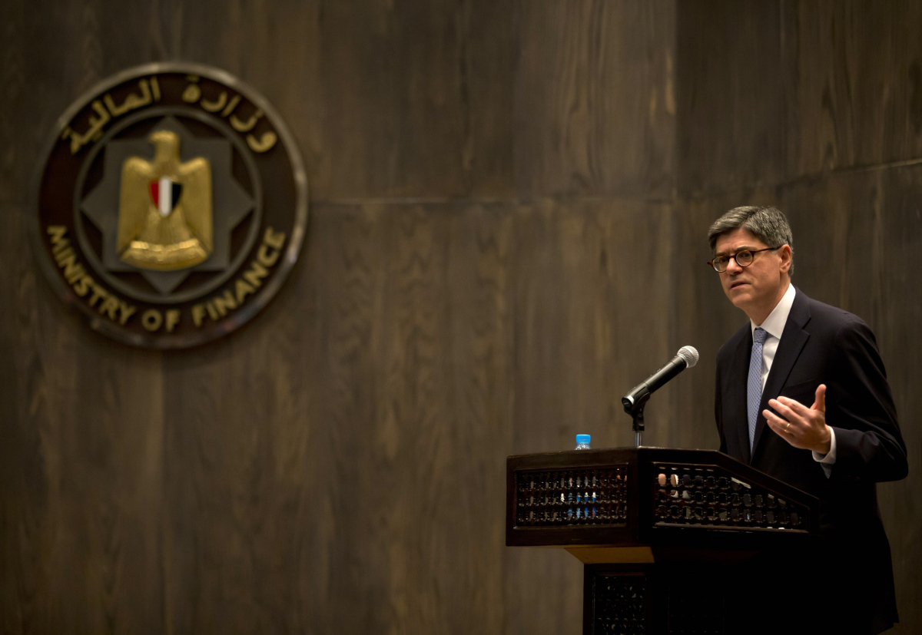US Treasury Secretary Jacob Lew gives a joint press conferece with Egyptian finance minister Hany Dimian (unseen) at the Egyptian Ministry of Finance in Cairo on Oct. 27, 2014. Hassan Ammar—AFP/Getty Images

A debt cancellation twice as large was approved by the IMF for Haiti in 2010
The Feds proposed Tuesday that the International Monetary Fund (IMF) cancel roughly $100 million in debt owed by Liberia, Sierra Leone and Guinea, which have been hit hardest in the current Ebola outbreak.
Collectively, the three countries owe $372 million to the IMF. U.S. Treasury Secretary Jack Lew said in a statement to Reuters that eliminating $100 million of that would strengthen the nations’ economies as they struggle to recover from the devastating effects of the virus, which has killed thousands.
“The International Monetary Fund has already played a critical role as a first responder, providing economic support to countries hardest hit by Ebola,” Lew wrote. “Today we are asking the IMF to expand that support by providing debt relief for Sierra Leone, Liberia, and Guinea.”
Treasury officials said the $100 million may be drawn from the IMF’s natural disaster debt relief fund. The fund was first used to cancel Haiti’s outstanding $268 million of debt owed to the IMF after the 2010 Haitian earthquake, the IMF said.
Without significant intervention in the Ebola outbreak, West Africa could lose up to 4% of annual growth and $25.2 billion of GDP by 2015, according to the World Bank.
[Reuters]
http://time.com/3579659/us-imf-ebola-debt/

IMF cuts blamed for weak response to Ebola
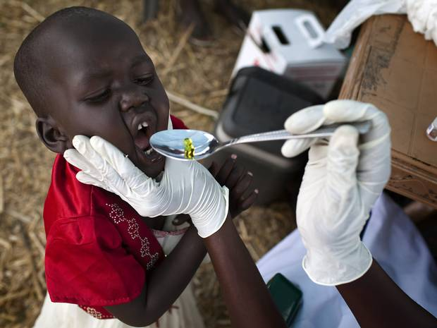

The IMF has faced regular criticism for requiring developing countries to adopt austere free-market policies
Matthew Moore
Monday 22 December 2014
107

Print
A A A
The International Monetary Fund has been accused of exacerbating the Ebola crisis by pressuring West African governments to reduce healthcare spending.
Policies pushed by the IMF, including limits on government spending and public-sector wage bills, left Guinea, Liberia and Sierra Leone unable to combat the virus effectively, according to Cambridge University researchers.
“A major reason why the Ebola outbreak spread so rapidly was the weakness of healthcare systems in the region,” said Cambridge sociologist Alexander Kentikelenis, lead author of a paper in the journal Lancet Global Health. “Policies advocated by the IMF have contributed to underfunded, insufficiently staffed and poorly prepared health systems in the countries with Ebola outbreaks.”
The IMF has faced regular criticism for requiring developing countries to adopt austere free-market policies as a condition of receiving loans and financial aid.
The men and women on the frontline against Ebola and other hazards
1 of 6

Next

The authors of the Lancet study claim that policies attached to IMF lending programmes in West Africa between 1990 and 2014 led to the weakening of already fragile healthcare systems.
An IMF spokesman said the researchers’ claims were “completely untrue”, adding that “since 2009, loans from the IMF to low-income countries have been at zero interest rates”, freeing up spending “on health and education”.
Last month, the IMF announced £190m in extra funding to fight Ebola in Guinea, Liberia and Sierra Leone.
http://www.independent.co.uk/news/world/africa/imf-cuts-blamed-for-weak-response-to-ebola-9939170.html

IMF policies blamed for weak Ebola response

Academics say demands for cuts to public spending and decentralised healthcare systems hampered ability of Sierra Leone, Liberia and Guinea to tackle spread of disease
94 | 125 | 0 | 3 | 222 | Email
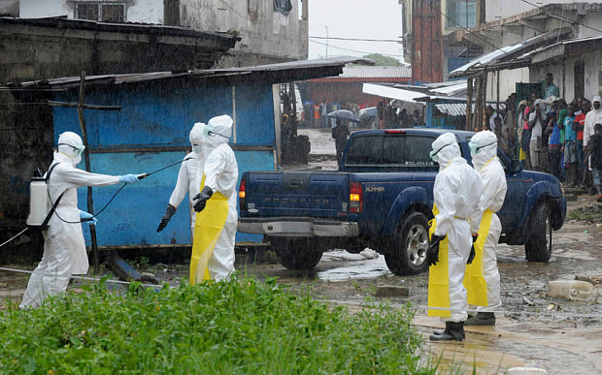
Health workers disinfect themselves in Monrovia, Liberia Photo: 2Tango/Reuters
By AFP
12:51AM GMT 22 Dec 2014
International Monetary Fund (IMF) policies left healthcare systems in the African countries worst affected by Ebola underfunded and lacking doctors, hampering a co-ordinated response to the outbreak, researchers said on Monday.
Links between the IMF and the rapid spread of the disease were examined by researchers from Cambridge University's sociology department, with colleagues from Oxford University and the London School of Hygiene and Tropical Medicine.
They found IMF programmes held back the development of effective health systems in Guinea, Liberia and Sierra Leone, the three countries at the epicentre of an outbreak that has killed more than 7,370 people.
Reforms advocated by the IMF hampered the ability of the health systems to cope with infectious disease outbreaks and other emergencies, the researchers found.
Alexander Kentikelenis, Cambridge sociologist and lead author, said: "A major reason why the Ebola outbreak spread so rapidly was the weakness of healthcare systems in the region, and it would be unfortunate if underlying causes were overlooked.

Related Articles
- 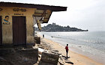
- Ebola: inside Liberia's West Point slum
16 Dec 2014
- Sierra Leone cancels Christmas over Ebola
12 Dec 2014
- Ebola: 'it's almost like another civil war'
05 Dec 2014
- The tablets that will tackle Ebola
29 Nov 2014
"Policies advocated by the IMF have contributed to underfunded, insufficiently staffed, and poorly prepared health systems in the countries with Ebola outbreaks."
The researchers examined policies enforced by the IMF before the outbreak, using information from IMF lending programmes from 1990 to 2014, and analysed their effects on the three countries.
They found the healthcare systems were weakened by IMF demands for economic reforms that cut government spending, capped the public sector wage bill and decentralised healthcare systems.
On the requirement to reduce government spending, researchers found that "such policies have been extremely strict, absorbing funds that could be directed to meeting pressing health challenges".
Lawrence Kind, Cambridge sociologist and co-author of the study, said: "In 2013, just before the Ebola outbreak, the three countries met the IMF's economic directives, yet all failed to raise their social spending despite pressing health needs."
The public wage cap meant the countries were unable to hire nurses and doctors and pay them adequately, while decentralised healthcare systems made it hard to mobilise co-ordinated responses to outbreaks of infectious diseases such as Ebola.
A spokesman for the IMF said that the organisation's mandate did not specifically include public health and that it was "completely untrue" that the spread of Ebola was a consequence of IMF policies.
"Such claims are based on a misunderstanding, and, in some cases, a misrepresentation, of IMF policies," the spokesman said.
"Since 2009, loans from the IMF to low-income countries have been at zero interest rate, which has freed up resources for countries to spend more on health and education."
The spokesman added that the IMF had provided a $130 million (£83m) financial package in September towards Ebola, and that they were working towards offering a package worth a similar amount to Guinea, Liberia and Sierra Leone next year.
http://www.telegraph.co.uk/news/worldnews/ebola/11307252/IMF-policies-blamed-for-weak-Ebola-response.html

High quality global journalism requires investment. Please share this article with others using the link below, do not cut & paste the article. See our Ts&Cs and Copyright Policy for more detail. Email ftsales.support@ft.com to buy additional rights. http://www.ft.com/cms/s/0/0f73ca78-8457-11e4-8cc5-00144feabdc0.html#ixzz3MmhCvdBF

Ebola-hit countries still servicing debt
Elaine MooreAuthor alerts
Ebola-stricken countries in west Africa are still servicing international loans in spite of calls from world leaders to cancel the debt and a pledge by the International Monetary Fund to provide relief.
In November the IMF announced that it would allocate an additional $300m to help the countries worst affected by the epidemic, easing financial pressure on Guinea, Liberia and Sierra Leone by cutting national debts and dispensing additional aid.

More

On this topic
- Signs of hope in Ebola-hit Sierra Leone
- Merck’s Ebola vaccine trial suspended
- Sierra Leone overtakes Liberia in Ebola
- Ebola vaccine shows promise in trials

IN Africa
- Zambia will need more help, says IMF
- Kenyan politicians clash on security bill
- S Sudan leaders fail to agree peace plan
- Buhari set to challenge Nigeria’s Jonathan

Sign up now
FirstFT is our new essential daily email briefing of the best stories from across the web
However, no debt reduction plan has yet been agreed and a proposal is not due to be presented to the board until next month.
Since the IMF announced its intention to provide debt relief, Sierra Leone has spent $2.3m on debt repayments and is scheduled to pay almost $2m before the end of the year, including $1.2m on Christmas Eve. The three countries together owe the IMF more than $480m.
Jubilee Debt Campaign said the repayments could have been used to increase public health spending to tackle the spread of the virus, which has so far killed more than 6,000 people.
G20 leaders in November called for more global action to tackle the virus and asked the IMF and World Bank to explore new mechanisms to address future crises.
Global organisations have already provided large sums to help tackle the spread of Ebola, including $130m of emergency assistance agreed by the IMF in September, and a further $130m interest-free loan expected to be made available in January. In addition, the World Bank is using $518m to pay for essential supplies and drugs and $450m from the International Finance Corporation to enable trade, investment and employment.
The three worst-affected countries are already the recipients of large disbursements by the IMF, which account for more each year than they pay out in debt servicing costs. They have also received debt cancellations in the past as part of the Heavily Indebted Poor Countries initiative and the Multilateral Debt Relief Initiative.
In 2006, Sierra Leone qualified for $1.7bn of debt cancellation, pushing the government’s debt payments down from 8 per cent of gross domestic product to 2 per cent. But borrowing since then has pushed this ratio back up and this year the country’s debt payments to GDP level is forecast to hit 8 per cent once more.
The economic impact of Ebola in west Africa is thought to be about $3bn-$4bn, according to the World Bank, although the final cost could rise if the affected countries seek further aid to rebuild their economies.
The overall rate of infections across west Africa has slowed in recent weeks, but Sierra Leone has suffered a rise in contagion, leading the government to place a ban on Christmas and New Year parties in an attempt to reduce transmission of the epidemic.
http://www.ft.com/intl/cms/s/0/0f73ca78-8457-11e4-8cc5-00144feabdc0.html#axzz3MmgbPnWr

