Two: 2nd = update

Japan to support Brazil in infrastructure improvement for stable imports of grain
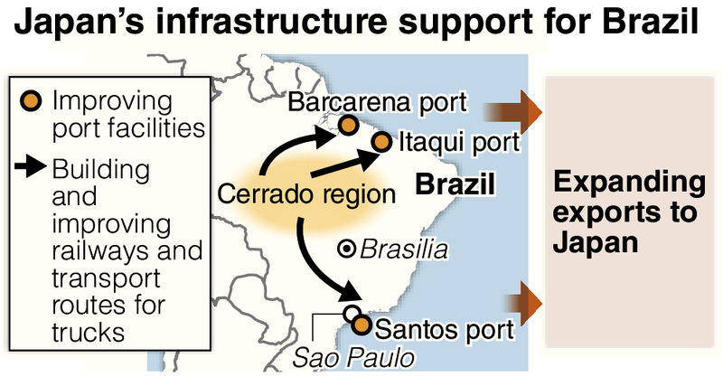
6:11 am, July 16, 2014
The Yomiuri Shimbun
The government will support Brazil in improving its ports, roads and railways among other infrastructure necessary to export grain, hoping to secure stable imports of grain from the South American nation, The Yomiuri Shimbun has learned.
Prime Minister Shinzo Abe is scheduled to visit five countries in Central and South America from July 25. He will announce the government’s full support in Brazil’s infrastructure development during the summit meeting with Brazilian President Dilma Rousseff, according to sources.
Brazil is one of the leading grain exporters in the world. In view of China’s growing demand for grain, Japan aims to stably import soybeans and corn to strengthen measures to tackle food security issues with the aid project.
Japanese companies, which receive low-interest loan from Japan Bank for International Cooperation, are expected to participate in the projects.
the-japan-news.com/news/article/0001426921
4:00 am, July 17, 2014
The Yomiuri Shimbun The Japanese government will help Brazil improve its ports, roads and railways, among other infrastructure necessary to export grain, hoping to secure stable imports of grain from the South American nation, The Yomiuri Shimbun has learned.
Prime Minister Shinzo Abe is scheduled to visit five countries in Central and South America from July 25, and he will announce the government’s support for developing Brazil’s infrastructure during a summit meeting with Brazilian President Dilma Rousseff on Aug. 1, according to sources.
Brazil is one of the leading grain exporters in the world. In view of China’s growing demand for grain, and with the aid project, Japan aims to create stable imports of soybeans and corn to help tackle food security issues.
Japanese companies, which receive low-interest loans from the Japan Bank for International Cooperation, are expected to participate in the infrastructure projects.
The companies will cooperate with local firms in improving the Itaqui export port in northern Brazil and other facilities, enabling larger grain carriers to dock at the port. New railways will also be constructed, while roads leading to ports will be widened to allow large trucks to use them. Major Japanese trading companies will expand investment in Brazilian companies related to the agricultural sector.
From 1979 to 2001, the Japanese government provided financial assistance for large-scale agricultural development in Brazil’s Cerrado grasslands region using the official development assistance program. The Cerrado region, in central Brazil, is one of the world’s leading grain-growing regions. Originally, the area was a dry wilderness and abandoned for a long period of time, but it was revived thanks to Japan’s development assistance. In the 30 years since Japan began the assistance, soybean production increased five times and corn increased three times, while soybean imports from Brazil to Japan increased about 10 times to 568,000 tons in 2008. Now, Brazil is the second-largest soybean exporter for Japan, following the United States.
the-japan-news.com/news/article/0001426921

