Two articles

Abe unveils $110 bil. in aid for Asia

- inShare
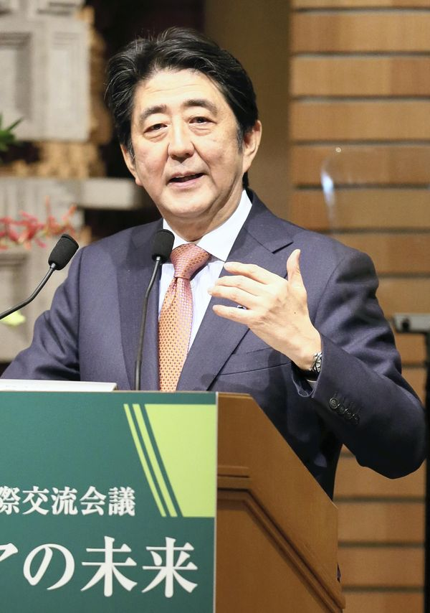
The Yomiuri Shimbun
Prime Minister Shinzo Abe unveils the Asian investment plan on Thursday in Chiyoda Ward, Tokyo.
8:03 pm, May 22, 2015
The Yomiuri Shimbun
Prime Minister Shinzo Abe has announced a policy to provide Asia with innovative infrastructure financing of $110 billion (about ¥13 trillion) in total over five years up to 2020.
The planned investment volume is 30 percent bigger than the about $85 billion provided over the last five years. The government is considering utilizing government financing as a method to attract private-sector funds, thereby providing assistance through joint efforts of the private and public sectors to fast-growing Asia.
Speaking at the banquet of the 21st International Conference on the Future of Asia held in Tokyo on Thursday, Abe called for unity in Asia, saying: “Shall we not work to create a fair and sustainable market that is not swayed by the arbitrary expectations of any country?”
By saying this, Abe aimed to emphasize Japan’s own approach to Asia’s infrastructure development in rivalry with the China-led Asian Infrastructure Investment Bank.
In concrete terms, the Japan International Cooperation Agency will increase its funds for low-interest, long-term yen credits and loans, and investments by 25 percent.
In collaboration with the Asian Development Bank, JICA will “establish a new funding mechanism for private-sector infrastructure projects,” Abe said. The Japan Bank for International Cooperation, for its part, will double its financial assistance by actively taking on short-term profit risk.
Infrastructure demand in Asia is said to amount to an estimated $800 billion (about ¥96 trillion) annually. The AIIB’s founding members have been negotiating their investment ratios with the aim of raising $100 billion in capital. It is widely believed that the AIIB will feature funding of low-cost infrastructure projects.
Abe stressed the need for high-quality infrastructure, using the phrase, “Penny-wise, pound-foolish.”
According to the International Monetary Fund, gross domestic product growth for 2015 is likely to top 6 percent in emerging and developing countries of Asia, compared with 2.4 percent for industrialized nations. The growth rate is especially high at 6.8 percent for China and 7.5 percent for India.

Slide 1 of 1
- 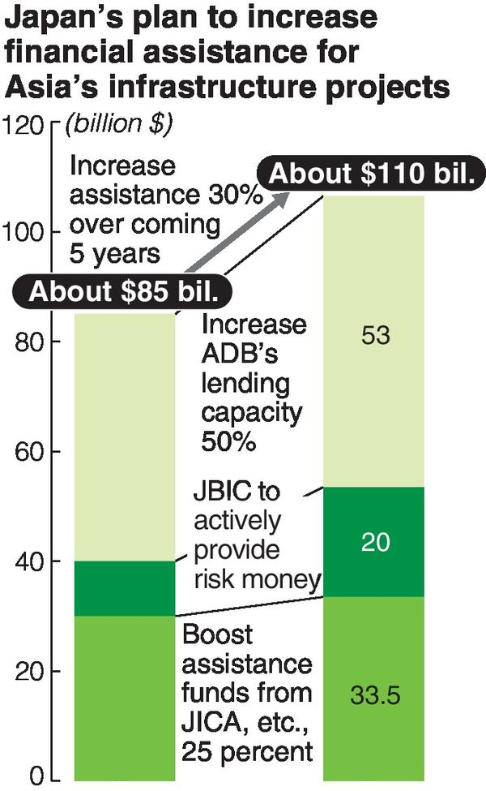
The Yomiuri Shimbun
These Asian countries want to accelerate growth by expanding their road networks, power generation and communications systems.
Japan’s past failure to sufficiently meet funding demands in Asia has led to Asian countries’ support for the establishment of the AIIB, observers said. JBIC and JICA, which are cautious about losses from bad debts, often take a long time to screen requests for loans. The same can be said of the Japan-led ADB.
So in the new financial assistance plan, Japan will take on risk more actively and speed up the procedure for lending, Abe said.
In cooperation with the ADB and the World Bank, which give consideration to conservation of the natural environment and human rights, Japan will expand its conventional assistance approach rather than eliminate it.
If drawing a distinction with the AIIB leads to greater demand for quality infrastructure, it is expected to push up exports by Japanese firms.
Environmentally friendly technologies, including highly efficient coal-fired power plants, high-speed rail and sophisticated water treatment systems, are fields of expertise for Japanese businesses.
Some people express concern that augmentation of financial assistance to emerging and developing countries will increase the risk of suffering huge losses. A senior megabank official said: “Investment in infrastructure projects in developing countries runs a high risk if made without government guarantees. It’s hard to go ahead with investment even if the government encourages ‘investment by the private sector.’”Speech
http://the-japan-news.com/news/article/0002169479

Japan unveils $110 billion plan to fund Asia infrastructure, eye on AIIB
May 21, 2015
REUTERS
Japan unveiled a plan on May 21 to provide $110 billion in aid for Asian infrastructure projects, as China prepares to launch a new institutional lender that is seen as encroaching on the regional financial clout of Tokyo and its ally Washington.
The amount of Japanese funds, to be invested over 5 years, tops the expected $100 billion capitalization of the Asian Infrastructure Investment Bank (AIIB), the Beijing-sponsored lender scheduled to begin operations next year.
Japanese officials said the plan, announced by Prime Minister Shinzo Abe at a symposium of Asian officials and experts, represents a 30-percent increase over Tokyo's past infrastructure funding.
Japan said it wants to focus on "high quality" aid, for example, by helping recipients tap its expertise in reducing pollution while building roads and railways. That's an implicit contrast with the AIIB, whose projects Washington has said may not adequately safeguard the environment.
"We intend to actively make use of such funds in order to spread high-quality and innovative infrastructure throughout Asia, taking a long-term view," Abe said in a speech announcing the plan.
About half the funds will be extended by state-affiliated agencies in charge of aid and loans and the rest in collaboration with the Asian Development Bank (ADB).
Japan hopes the aid will help draw private funds to help meet the vast demand for infrastructure in Asia.
The United States and Japan were caught off guard when a total of 57 countries, including Group of Seven members Britain, Germany and France, jumped on board the AIIB bandwagon by March.
The two allies have stayed out of the China-led institution, seen as a rival to the U.S.-dominated World Bank and Japan-led Asian Development Bank, citing concerns about transparency and governance --although Tokyo for one is keeping its options open.
Finance officials said Japan's aid plan had long been in the works as part of a Group of 20 pledge to meet global needs.
But worried that Japan may look less proactive than Beijing, Tokyo also wants to showcase its support for the region.
"We had thought it was better not to speak up much, but that doesn't get through," Koichi Hagiuda, a special aide to Abe in his Liberal Democratic Party, told Reuters.
"So some demonstration seems to be needed."
Japanese and Chinese finance officials will meet in Beijing on June 6 and may discuss the AIIB, but Tokyo looks unlikely to make a decision on joining any time soon.
LDP lawmakers looking into the matter will put together a report later this month or in early June, but will only state the pros and cons of joining or staying out, said Masahiko Shimayama, a member of the party panel.
"I think it's unlikely that the government would make a decision on when to join based on our report," he told Reuters.
Tokyo, which given the size of its economy could become the No. 2 donor if it decides to join the AIIB, may well keep its powder dry for some time to come.
"If it (AIIB) becomes a proper financial institution for the sake of Asia, there is no reason to be embarrassed about joining later," Hagiuda said.
The United States and Japan agreed last month that the World Bank and ADB should team up with the AIIB in syndicated loans as a way to help the new lender establish strong standards.
The AIIB is holding a meeting of founder members in Singapore this week to decide on the articles of association and operational details. A delegate to the conference, speaking on condition of anonymity, said it was unlikely the new bank could start lending at the start of 2016 as predicted, given the need for member countries to get approvals from their legislatures.
"China hopes that members get such approvals by year-end and the operations start from the next year," said the Asian delegate. "But I wonder if it is possible, given domestic political situations in each country."
REUTERS

http://ajw.asahi.com/article/behind_news/politics/AJ201505210107

