Leak reveals Future Fund and multinationals' secret offshore tax deals
Date
November 7, 2014 - 12:13AM

Georgia Wilkins and Gareth Hutchens
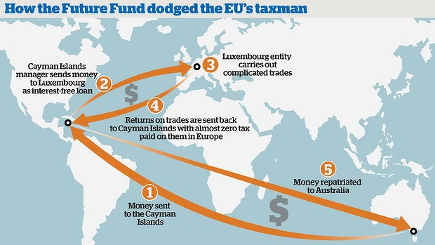
Directors of the Australian government's Future Fund as well as PricewaterhouseCoopers, Macquarie and AMP could be forced to face a Senate inquiry into tax avoidance following a global investigation into secret tax deals in Luxembourg.
Thousands of leaked documents published by the International Consortium of Investigative Journalists on Thursday revealed how Australian and multinational companies used accounting firm PwC to strike deals in Luxembourg to shift profits and avoid tax.
The revelation comes amid a fierce debate about corporate tax avoidance and profit shifting in Australia and less than 10 days before the federal government is due to host the G20 Leaders Summit in Brisbane on November 15.
The involvement of the Future Fund puts Australia in an awkward position as it makes the case for multilateral support on the issue of tax evasion - a key issue on the agenda.
Tax Commissioner Chris Jordan has called for a joint investigation into the data with Australia's tax treaty partners.
The leak has also triggered calls for the directors of the companies - including those of the government's sovereign wealth fund - to be brought before a Senate inquiry into tax avoidance next year.
"These companies can't be allowed to roll out their tax lawyers and spin doctors to make this go away," Greens leader Christine Milne said.
"The Greens will be pushing for directors of companies with fiduciary responsibility to be brought before the Senate inquiry and held accountable to the Australian Parliament and the Australian people."
The government's Future Fund was one of the groups using PwC to negotiate secret tax deals in the tiny European country, documents show.
It used a complex structure involving interest-free loans to significantly reduce its tax bill through subsidiaries in the Cayman Islands and Luxembourg.
The Future Fund declined to comment on Thursday. Managing director David Neal told The Australian Financial Review the structure was "commonly used by institutional investors and external investment managers".
Finance Minister Mathias Cormann defended Australia's anti-tax avoidance laws in the wake of the leak.
He said the government was implementing new policy changes, strengthening tax administration and pursuing multilateral change to deal with tax minimisation strategies.
"The government is firmly committed to ensuring that Australian tax is paid on profits earned in Australia," he said. But Labor accused the government of draining the ATO's resources at the very time the country was making critical steps in the global fight against tax avoidance.
"This case again highlights the need for more transparency about the tax arrangements of big multinationals," shadow assistant treasurer Andrew Leigh said.
PwC said in a statement on Thursday it gave advice to all companies "in accordance with applicable local, European and international tax laws".
The Business Council of Australia declined to comment on the data, instead standing by a speech given by its chief executive, Jennifer Westacott.
The speech criticised a recent debate about the lack of tax paid by multinationals, triggered in part by a report by the Tax Justice Network that revealed the use of tax haven subsidiaries by ASX 200 companies and claimed billions were being potentially forgone in corporate tax.
"Of course, businesses have to accept their obligations when it comes to paying tax and being transparent," Ms Westacott said. "But we should also acknowledge the contribution made by business. More than $70 billion of company tax is expected to be collected this year."
Mark Zirnsak of the Tax Justice Network said the data vindicated concerns Australian companies were not paying their fair share of tax.
"This latest leak of information absolutely confirms the need for Australia to push ahead with the OECD's base erosion and profit-shifting agenda to deal with these kinds of alleged tax dodging arrangements," he said.
Property groups Lend Lease and Goodman Group were also among the Australian companies named as using PwC to set up secret tax deals in Luxembourg. Ikea was also prominent in the documents, detailing how it exported half of its billion-dollar profits tax-free to tax havens.
Lend Lease said the documents related to "legitimate structures which were considered non-core assets".
"Lend Lease has business operations in a number of jurisdictions and complies with the tax laws in those jurisdictions and the Australian tax laws which seek to assess the taxation profits from those operations."
A Macquarie spokeswoman declined to comment on the tax leak.
AMP said it did "not use hybrid loans and does not employ base erosion profit-shifting arrangements".
PwC said in September that Australia should lower its corporate tax rate from 30 per cent to 25 per cent to increase economic growth.
"This is the bigger picture on base erosion and profit shifting. Instead of redistributing the pie, let's grow the pie for all Australians," managing partner of tax and legal Tom Seymour told a tax forum in September.
The ATO has abandoned several agreements with multinationals due to aggressive tax planning.
Deputy commissioner Mark Konza said the ATO had not yet looked at the ICJC documents, but that those arrangements with the Luxembourg authorities had been entered into years ago and were not likely to continue to be possible under the OECD and G20 plan against tax evasion.
With Carolyn Cummins and Nassim Khadem
Read more: http://www.smh.com.au/national/investigations/leak-reveals-future-fund-and-multinationals-secret-offshore-tax-deals-20141106-11hrf5.html#ixzz3IIgv4dZX

