Ghana in talks with IMF as debt problems deepen
Tim Jones
19 August 2014
Ghana is to hold negotiations with the IMF in September on a new loan programme following a fall in the currency which has increased the level of debt payments. Under any programme the IMF is likely to require cuts in the civil service wage bill and removal of fuel subsidies.
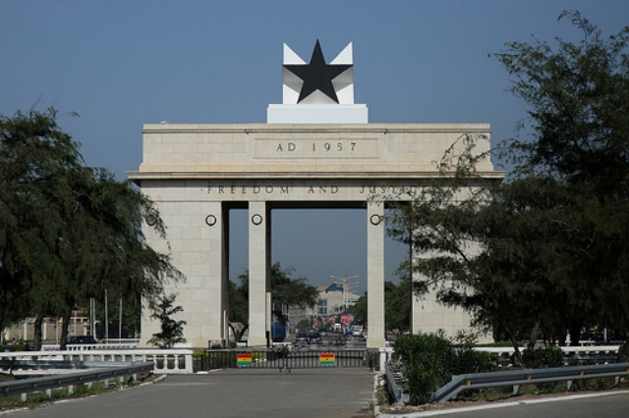
Independence Square, Ghana (Credit: CC Chapman)
The West African country had $7 billion of debt cancelled in 2005. However, the government’s external debt has increased from $2.3 billion in 2006 to $12.6 billion in 2014. During the IMF’s last review earlier this year debt payments were projected to be 12 per cent of government revenue this year, rising to 20 per cent by the early 2020s.
Moreover, the Ghanaian cedi has devalued by around 40 per cent since the start of the year, according to market currency calculators (the Ghanaian Central Bank claims it has devalued by 23 per cent). This increases the relative costs of Ghana’s debt payments as the government’s income is in cedi’s, but the external debt payments are mainly in US dollars or other foreign currencies. The IMF review predicted that a one-off depreciation (it doesn’t say how large) would increase debt payments to 15 per cent of revenue this year, and over 30 per cent by the early 2020s.
Bernard Anaba from the Integrated Social Development Centre in Accra says:
“Nobody would have expected such a rapid increase in debt. The debt relief gave us breathing space but the campaign has been forgotten too soon.”
Ghana’s debt includes bonds it has issued on international markets, with interest rates of almost 9 per cent. These therefore make-up a large part of Ghana’s debt payments, though so do debt payments to foreign governments and multilateral institutions. And of Ghana’s total external debt, 43 per cent is owed to multilateral institutions, the bulk of which is owed to the World Bank (29 per cent of Ghana’s total external government debt).
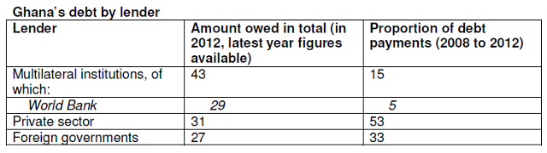

jubileedebt.org.uk/blog/ghana-talks-imf-debt-problems-deepen

